Ultrasonic Plastic Welder Manual
(JYD-H80/H80S)

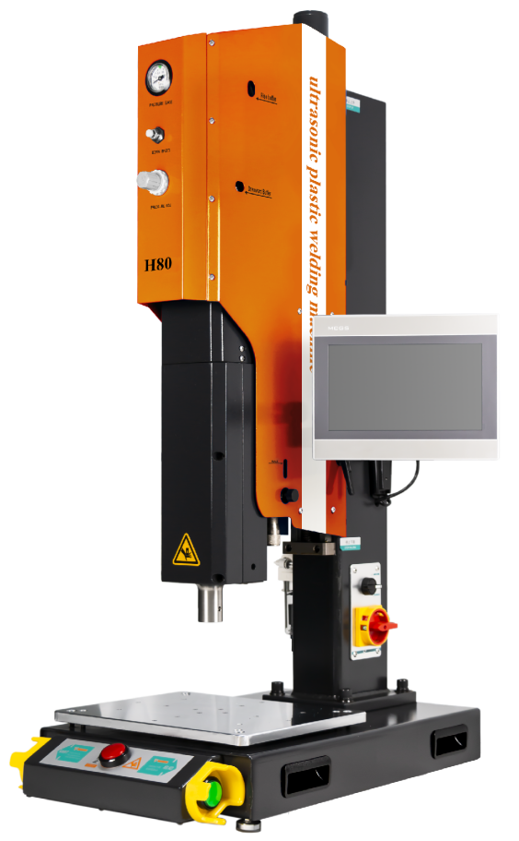

Contents
1. Introduction............................. 3
2. Safety Tips 3
3. Installation Position 4
4. Power Supply 4
5. Welding Principle 5
6. Diagram of machine parts 6
7. Connection ports 7
7.1 Power Supply....................... 7
7.2 Power connection interface/external control input/output interface 7
7.2.1 Input/output control interface (DB25) 7
7.3 Power connection interface/external control input/output interface 8
8. Port wiring 9
8.1Control input port................. 9
8.2Work state output port.......... 9
8.3 Analog quantity input/output port 9
8.4Communication port............. 10
8.5 HMI (human machine interface) communication port 10
9. Operation interface 11
9.1 Password keyboard, parameter keyboard and mould naming keyboard 11
9.2 Version information interface 12
9.3Welding record interface ...............................................12
9.3.1Data management............... 13
9.4Data statistics interface......... 14
9.4.1Power curve interface........ 14
9.4.2Curve adjustment................ 15
9.5 Trigger preparation interface 16
9.5.1 Interface functions and parameter scope 16
9.6 Parameter setting interface 17
9.6.1 Interface functions and parameter scope 17
9.7 Quality management interface 19
9.7.1 Interface functions and parameter scope 19
9.8 Protection function interface 20
9.8.1 Interface functions and parameter scope 20
9.9 Factory settings interface 21
9.9.1 Interface functions and parameter scope 21
9.10 Amplitude calibration interface 22
9.10.1 Interface functions and parameter scope 22
9.11 Pressure calibration interface 23
9.11.1 Interface functions and parameter scope 23
9.12 Contact information interface 24
9.12.1Interface function.................... 24
10. Troubleshooting 25
11. Quality assurance 28
12. Additional Explanation 29
13. Contact Us 30

1. Introduction
Dear Users,
Thank you for choosing JYD-H80/H80S ultrasound product. It is an intelligent digital ultrasound welding machine researched and developed by us. We use perfect and optimized real-time phase-locked loop tracking technology in developing this series, which achieves more stable and reliable operation. Flexible human-machine interface configuration gains more flexible product application.
Before installing and using the product, please carefully read through the operation manual and get familiar with product operating specifications and applicable parameter scope.
No professional or non-professional technician without being trained or authorized by our company cannot debug or maintain this product without permission; Any improper operation will cause operation failure, fault or irreversible damage, and may even cause safety accident.

Safety Tips
Please carefully read through this manual before operating the equipment, for the sake of normal equipment operation and self-safety as well.
This manual shall be conveniently accessible to operation and maintenance personnel to read through.
The product has to be installed by professional technicians.
Operators have to take proper operation specification trainings. It is necessary to take corresponding protection measures to use the product on occasions where dangerous explosion may occur.
Since partial energy will be converted into heat during ultrasound welding, it is required to make sure that accumulated heat will not cause possibility of explosion or burning under conditions where no corresponding measure is taken.
Electro-magnetic compatibility of surrounding electric equipment shall meet the requirements in relevant national standards.
Users may make necessary setting to operation parameters, but set those with encrypted protection according to delivery default or this manual. If any question, please contact with our technicians.
Under no circumstance shall the equipment be started when the mold is loose.
If there is any abnormal condition and the fault is not solved, please do not re-start to avoid fault spreading.
Equipment movement or maintenance has to be conducted by professional technician with the equipment fully powered off.
Generator shall be blown by filtered dry compressed air for dedusting or swept by brush during maintenance. Please do not use cleanser or spray to clean generator enclosure and LCM interface which shall be wiped by cloth wet by water.
High-frequency load-driving cables and cables controlling and monitoring signals shall be stranded wires with shielding. Please do not stay too close to installation site of energized equipment and large-current conductors.
Shielded wires shall be connected to grounding wire end controlling power source.
Grounding wire end of all drive wires and control wires shall be connected to ground terminal, and ground terminal of generator shall be directly connected to grounding wire end of power supply source with conductors.
Attention shall be frequently paid to fault information code indicated by power source, and corresponding measures shall be taken earlier to avoid fault spreading.

Power source shall be installed in correct direction, stable with no looseness.
Make sure power supply specifications meet requirements for power supply
Do not roll up high-frequency load driving cables and temperature sensor wires if they are too long for installation, because this will cause over-high temperature and influence measurement precision. Connecting wires shall be shortened to required length.
Data parameters and function settings shall be recorded and filed after installation and debugging for reference if necessary. Cables connected to power supply cannot be randomly changed.
If any of the following conditions occurs, maintenance can be conducted by professional technical engineers when generator is fully powered off:
There is liquid or metal conductive object in power supply.
Power supply wires get loose or damaged.
Power supply gets loose.
Displayed power supply content is apparently different from standards for normal operation.

Installation Position
Some power devices will cause heat when power supply works, over-high temperature rise will cause excessive protection in power supply (refer to description to "overheat" faults for details). We apply forced air cooling for this. Therefore, it is necessary to make sure that distance from generator air vent to surrounding shelter is not smaller than 10CM. Besides, it is still required to avoid being installed on sites with ambient temperature over 40℃ and humidity over 75%.

Power Supply
Power input specifications: AC 220V 50/60HZ. Try to use three-core cables with grounding wire to connect to generator power input connector. Please open the enclosure before replacing power protection fuse inside power supply.

Welding Principle
Ultrasonic welding is to convert 50/60 Hz current with ultrasonic generator into 15, 20, 30 or 40 KHz high-frequency power which is then output to piezoelectric ceramic of transducer to enable the transducer to produce mechanical shock of the same frequency which is transmitted to welding head through amplitude-change pole device. Welding head transmits received vibration energy to joint part of workpieces to be welded, and vibration energy is then converted into heat through friction to weld products in this area.

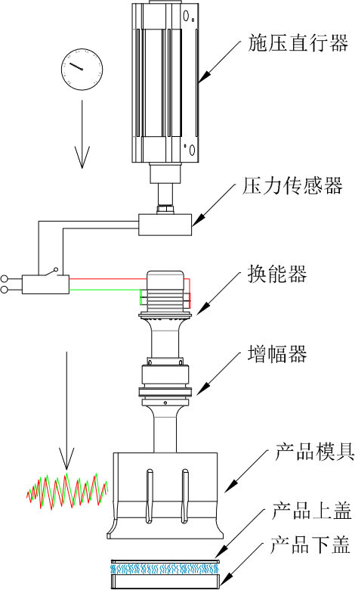
Pressure actuator
Product mold
Pressure sensor
Energy converter
Amplifier
Lower cover
Upper cover

Diagram of machine parts
Air pressure display gauge
Rising buffer
Air pressure display gauge
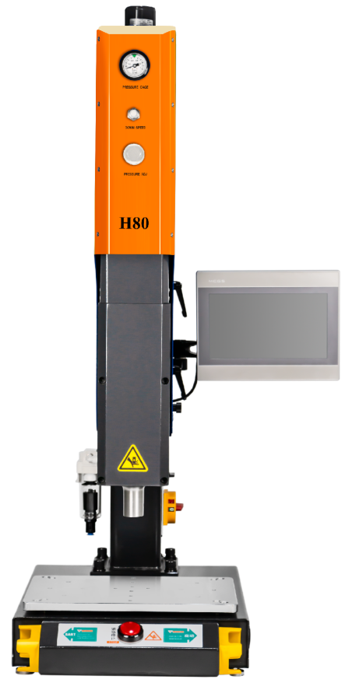
Adjustment of descending speed
Adjustment of descending speed

Pressure regulating valve
Descending buffer
Pressure regulating valve

Fixed handle for lifting
Size of the touch screen: 200×150mm

Down limit adjusting screw

Limit fixing screw
Automatic lifting button
Fixed handle for lifting
Emergency stop switch
Power supply switch
Limit fixing screw
Oil-water separator
Starting switch

Emergency stop switch

Power supply switch
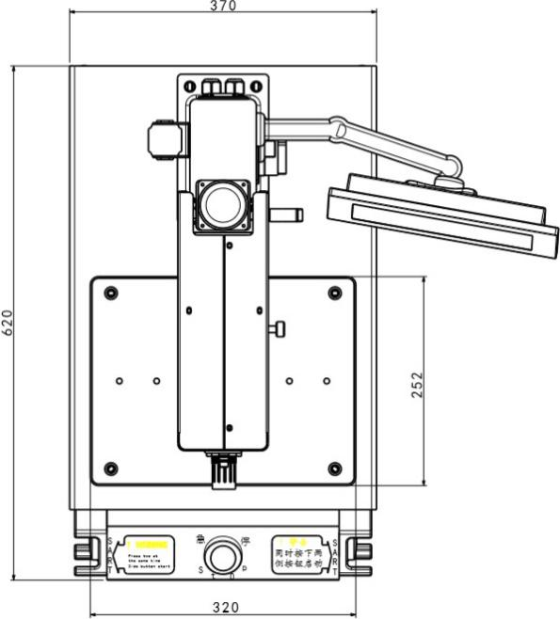
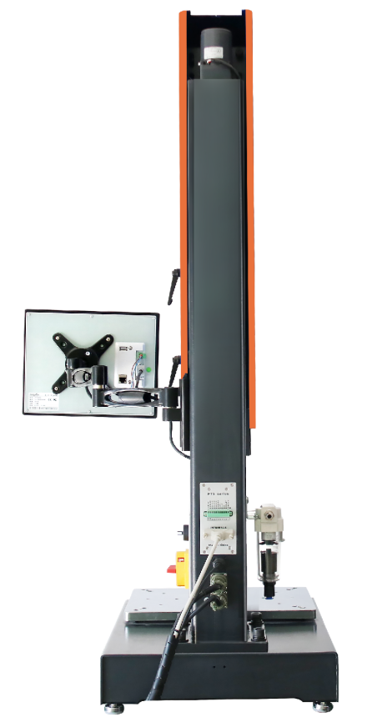
Emergency stop button

Oil-water separator
Power supply switch
Automatic lifting button
Fixed handle for lifting
Side view
Rear view
Work table
Front view
ON- press the two buttons simultaneously
Touch screen bracket
Side view
Top view
Work table

Connection ports

7.1 Power Supply
Power input specifications: AC 220V 50/60HZ。

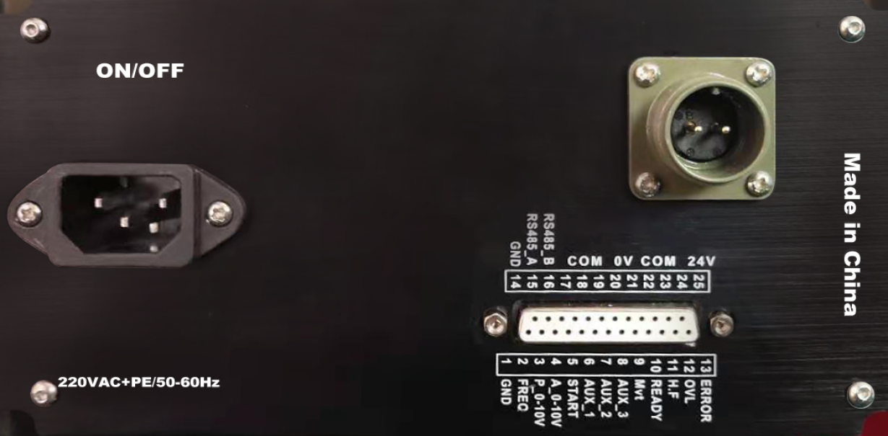
7.2 Power connection interface/external control input/output interface

7.2.1 Input/output control interface (DB25)

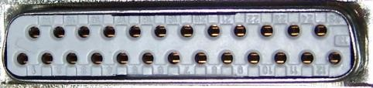
14 15 16 17 18 19 20 21 22 23 24 25
1 2 3 4 5 6 7
8 9 10 11 12 13
ERROR
OVL
COM_24V
COM_24V
H.F
COM_24V
READY
COM_24V
Mvt
COM_0V
AUX_3
COM_0V
AUX_2
COM_0V
AUX_1
COM_0V
START
COM_0V
A_10V
RS485_B
P_10V
GND
GND
RS485_A
FREQ

7.3 Power connection interface/external control input/output interface

Pin | Name | Status | Description
C1_10 | Start | Input port | Ultrasonic starting (Note 1)
C1_9 | AUX_1 | Input port | Standard machine model: Ultrasonic searching; Program control model: Trigger ultrasonic starting (Note 2)
C1_8 | AUX_2 | Input port | Standard machine model: Amplitude grading; Program control model: Emergency stop (Note 3)
C1_7 | AUX_3 | Input port | Standard machine model: Vibration control; Program control model: Grounding detection (Note 4)
C1_11 | COM_0V | Input port | Public end of input port
C1_2 | READY | Output port | "Ready" state output
C1_3 | Mvt | Output port | "Curing" state output (Note 5)
C1_4 | H.F | Output port | "Ultrasonic work" state output (Note 6)
C1_5 | OVL | Output port | "Overload" state output (press resetting button or ultrasonic searching input to eliminate the state)
C1_6 | ERROR | Output port | "Fault" status output (Note 7)
C1_1 | COM_24V | Output port | Public end of output port
C3_1,C3_2 | 24V | External control power supply | 24V output + pole (24V/1A) (Note 8)
C3_3,C3_4 | 0V | External control power supply | 24V output - pole (Note 8)
C2_1 | A 0_10V | Amplitude control | Amplitude control input 0-10V (10-100% amplitude)
C2_2 | P 0_10V | Power output | Power output 0-10V (10-100% rated power)
C2_3 | FREQ | Frequency output | Frequency pulse output (3.3V/10mA)
C2_5 | RS485_A | Communication port | RS485(MODBUS_RTU) communication interface
C2_6 | RS485_B | Communication port | RS485(MODBUS_RTU) communication interface
C2_4 | GND | Internal power ground | Public land of internal power supply (public land of C2 port)

Port wiring

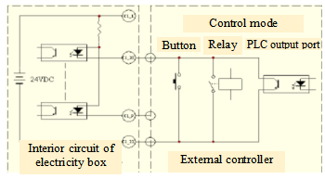
8.1 Control input port

8.2 Work state output port

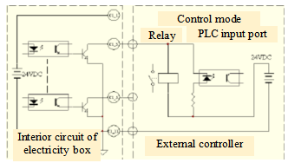

Note: The maximum driving current for 24V power input is 1A.

Please use shielded wire as signal wire, with wire diameter >=0.3mm2 and length not exceeding 6m.

8.3 Analog quantity input/output port
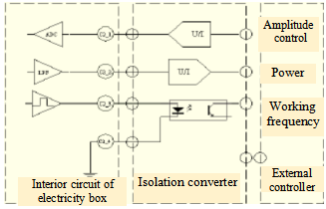

Note: Analogue quantity input and output ports have to be set with isolation switching circuits outside. Frequency port 3.3V/10mA TTL level output

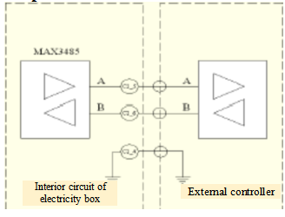
8.4 Communication port

Note: RS485 communication interface shall be isolated on strong-interference site with shielded twisted pair.

8.5 HMI (human machine interface) communication port

Definition of communication wiring

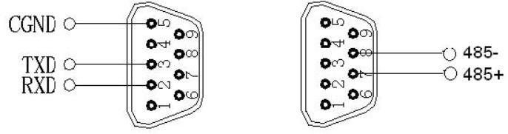

Note: Human-machine interface of the equipment applies RS485 communication, baud rate 115200, data format 8/N/1 and big-endian and little-endian.

Operation interface

In the following is the instruction to functions of JYD-H80/H80S interface and operations: JYD-H80/H80S non-power curve, pressure calibration interface (without pressure control) and part of sub-functions and modes.

9.1 Password keyboard, parameter keyboard and mould naming keyboard

Password keyboard: Password input keyboard has blue background, set with keys for figures, backspace, resetting, exit and confirmation;
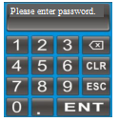

Parameter keyboard: Parameter keyboard has green background, set with keys for figure, backspace, resetting (or +/-), exit and confirmation;

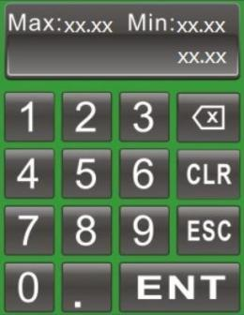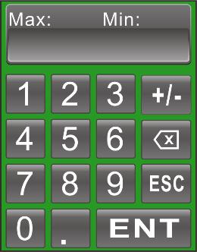

9.2 Version information interface

This interface will be displayed by default at startup. After no operation for about 6s, it will skip to the Welding Record Interface, Production Statistics Interface or Power Curve Interface (it will automatically skip according to the interface last displayed before previous shutdown).

The interface displays rated power, rated frequency, version and date.

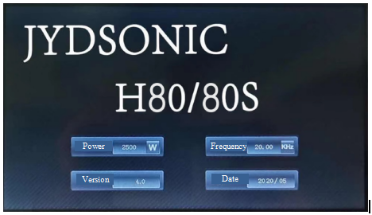

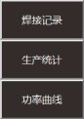

9.3 Welding record interface

Click button in the Menu Bar, select this sub-menu button in the pop-up window below it and then click on Welding Record to enter the interface.

The interface displays welding records, real-time welding power and data management operations.
Note: The data on the barcode scanner are shown in the area marked by the dotted line in the figure below. When the barcode scanner is not connected, there is no content in this area.
Note: Please do not shut down the equipment directly after finishing welding, and wait 40s to avoid loss of form data.

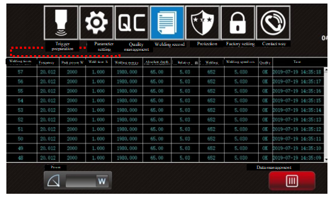

9.3.1 Data management
Click the Data Management Button Open the Data Management Menu and then click on the corresponding button as required.
Clear: It starts to count from 1 again (unrecoverable), with recorded form data not deleted.
Delete record: Delete form data records (unrecoverable), with count value unchanged.
Data export: Click the button to output historical form data records and scanning data to the U disk after inserting it. The data table is named H80 + "current time". CVS. The interface will prompt "Data output is successful" when the data are output successfully.

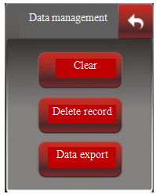

9.4 Data statistics interface

Click button in the Menu Bar, select this sub-menu  button in the pop-up window below it and then click on Production Statistics to enter the interface.

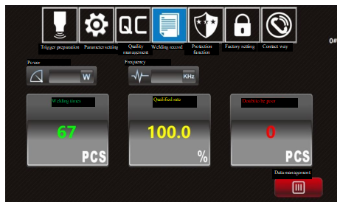

9.4.1 Power curve interface
Click button in the Menu Bar, select this sub-menu 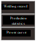 button in the pop-up window below it and then click on Power Curve to enter the interface.

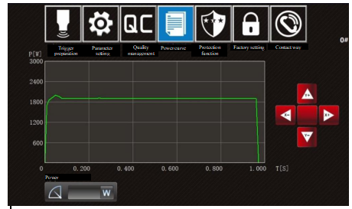

9.4.2 Curve adjustment

Within a certain period of welding time and a peak power range (welding time > 0.1S, peak power > 250W), the X-axis and Y-axis can be zoomed in real time through the clicking on the buttons shown in the figure below.

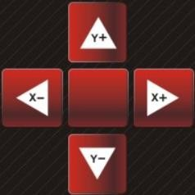

9.5 Trigger preparation interface

Click button in the Menu Bar to enter into this interface. When entering into the interface of trigger preparation, parameter setting and quality management for the first time, the interface password which is "1234" by default shall be entered.

As a debugging interface, the interface can observe power, frequency and real-time impedance, set corresponding preset values, and choose settings of amplitude, trigger mode and others based on actual working conditions and using demands. The equipment temporarily stops after entering the interface, and switches to manual mode. Press external emergency stop button for resetting.

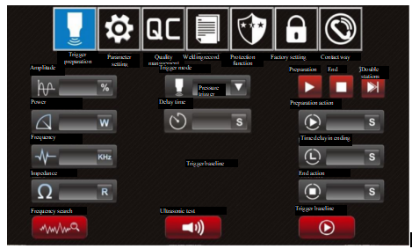

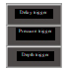
9.5.1 Interface functions and parameter scope
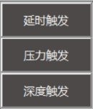  Selection of trigger mode: | I. Delay trigger: Vibration delay 0-10S;
 | II. Pressure trigger: vibration pressure point: 10-2,000N;
 | Ⅲ. Depth trigger: vibration depth point: from 1.00mm to the absolute depth.
Frequency search: | Search real-time frequency (inching).
Ultrasonic test: | Ultrasonic function test (long-pressing).
Trigger preparation: | Debug to simulate the trigger point. When the trigger is on, the device will press downwards. After vibration is caused, the device will automatically return back.
Preparation: | Preparation Action Switch (green when it is on);  Preparation action: 0-10S。
End: | End Action Switch (green when it is on);  End action: 0 -10S；  Time delay in ending: 0-10S.

9.6 Parameter setting interface

Click button in the Menu Bar to enter the interface.

Select and set corresponding parameters on the interface.

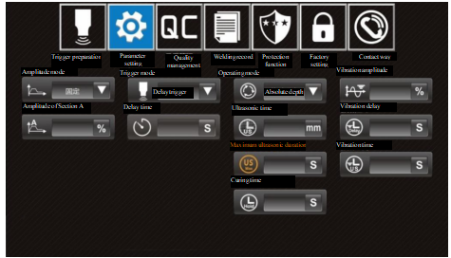

9.6.1 Interface functions and parameter scope
Amplitude mode: | I. Fixed: Single-amplitude mode. Only the amplitude of section A is displayed for setting. Setting range: 10-100%;
 | II. Grading: Dual-amplitude mode, displaying and setting amplitudes of Section A and B and proportion of Section A;
 | Setting range:Amplitude of Section A: The same as fixed mode;
 | Amplitude of Section B: 10-100%.
 | Proportion of Section A: 10-100%.

Note: Proportion of Section B is not displayed, being "100%-proportion of Section A".

Trigger mode: The same as trigger preparation interface.
Operating mode: | I. Time: weld time 0-10S;
 | II. Energy: welding energy 0-6,000J;
 | III. Grounding: Grounding duration: 0-10S;
 | IV. Absolute depth: Absolute welding depth: 0-100mm;
 | V. Relative depth: Relative welding depth: 0.01-100mmm
Maximum ultrasonic duration: | Maximum ultrasonic duration of welding machine: 0-10S.
Curing time: | Curing cooling lasts 0-10S after finishing welding.
Vibration amplitude: | Ultrasonic secondary vibration amplitude is 10-100% after curing.
Vibration delay: | Ultrasonic secondary vibration delay is 1-10S.
Vibration time: | Ultrasonic secondary vibration time is 1-10S, and secondary vibration is prohibited when it is set as 0S.
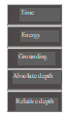

9.7 Quality management interface

Click the button in the Menu Bar to enter into this interface.

The interface can turn on/off corresponding quality management switches and set quality monitoring scope by clicking pointer disk; The pointer shown in red refers to the start-up.

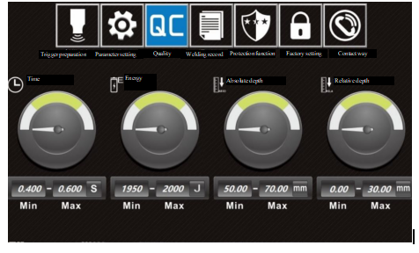

9.7.1 Interface functions and parameter scope

Time: | 0-10/S.
Energy: | 0-60000/J.
Absolute depth: | 0-100/mm.
Relative depth: | 0-100/mm.

Note: When the maximum value is zero, it is required to set the maximum value first.

9.8 Protection function interface

Click button in the Menu Bar to enter the interface and the interface password is "1962". The interface can set corresponding protection parameters.

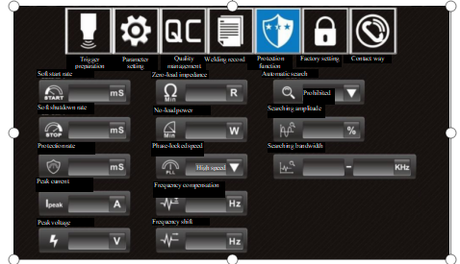

9.8.1 Interface functions and parameter scope
Phase-locked speed: | High, fast, medium and low speed. Phase-locked rate.
Automatic search: | Prohibition, On, Once per Minute and Startup.  The frequency will be searched automatically in standby mode.
Searching amplitude: | 0-1%.
Searching bandwidth: | 13-70KHz.
Soft start rate: | 10-2000mS. For ultrasonic soft start speed, the larger the figure is, the longer the soft start will be.
Soft shutdown rate: | 10-2000mS. For ultrasonic soft shutdown speed, the larger the figure is, the slower the shutdown will be.
Protection rate: | 1-100mS. For protection reaction speed, the smaller the figure is, the more flexible the protection will be.
Peak current: | 1-25A.
Peak voltage: | 500-4000V.
Zero-load impedance: | 15-100Ω.
No-load power: | 10-500W.
Frequency compensation: | ±500Hz.
Frequency shift: | ±99Hz.

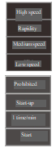

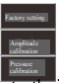

9.9 Factory settings interface

Click button in the Menu Bar, select this sub-menu button in the pop-up window below it and then click on Factory Settings to enter the interface. The interface password is "2005".

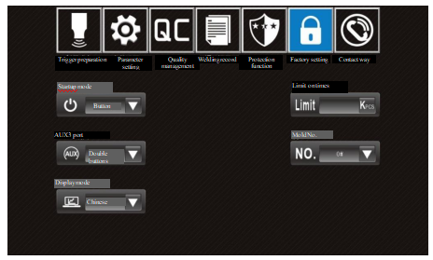

9.9.1 Interface functions and parameter scope

Startup mode: | Button, PLC.
AX3 port: | Grounding, Light Curtain, Dual Button.
Model No: | 1-10#; You can select the corresponding mould number as required and then the system parameter will automatically change to the original stored value of the number. You can click on "Mould Number Setting" to change the name of the selected number.

Note: When selecting the corresponding mould number for the first time, you need to carry out debugging and correction to set the corresponding parameters.

Display mode: Chinese, LOGO and English.
Limit on times: 0-60000.

9.10 Amplitude calibration interface

Click button in the Menu Bar, select this sub-menu 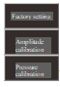 button in the pop-up window below it and then click on Amplitude Calibration to enter the interface. The interface password is "8080".

Constant amplitude debugging steps: 1. Choose "calibration" as constant amplitude function; 2. Amplitude is set as 100%; 3. Long press ultrasonic testing button; 4. Observe system parameters and constant amplitude data; 5. Input the minimum and maximum values of observed constant amplitude data within the constant amplitude scope; 6. Choose "Allowed" for constant amplitude function.

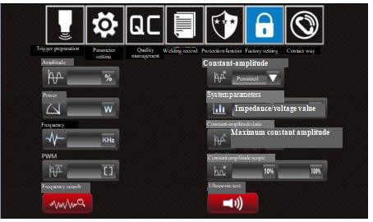

9.10.1 Interface functions and parameter scope

Frequency search: | The same as trigger preparation interface.
Ultrasonic test: | The same as trigger preparation interface.
Constant amplitude function: | Allowed, calibration and prohibited.
Constant amplitude scope: | 20-999.

9.11 Pressure calibration interface

Click button in the Menu Bar, select this sub-menu 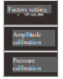 button in the pop-up window below it and then click on Pressure Calibration to enter the interface. The interface password is "8410".

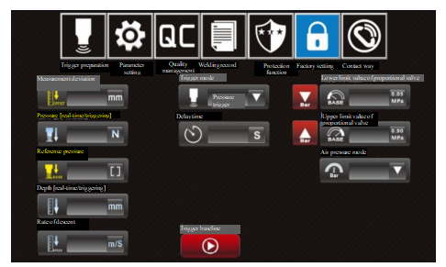

9.11.1 Interface functions and parameter scope
Trigger preparation: | The same as trigger preparation interface.
Delay time: | The same as trigger preparation interface
Reference pressure: | 0-1000N.
Measurement deviation: | From 0 to trigger depth.
Lower limit switch of proportional valve: | Lower limit benchmark switch of proportional valve (turning green when it is on)
Lower limit value of proportional valve: | Lower limit benchmark value of proportional valve: 0-Max.
Upper limit switch of proportional valve: | Upper limit benchmark switch of proportional valve (turning green when it is on)
Upper limit value of proportional valve: | Upper limit benchmark value of proportional valve: Min-4,000.

9.12 Contact information interface

Click button in the Menu Bar to enter the interface.

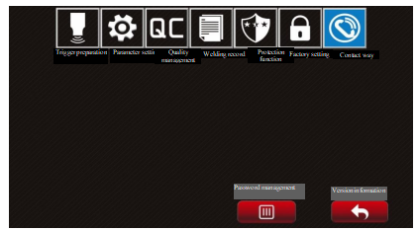

9.12.1 Interface function
Password management: | After entering the password (initial password "1234"), it can be changed or removed.
 | 1. Password change: The passwords of trigger preparation, parameter setting and quality management interface can be changed, while the passwords of other interfaces cannot.
 | 2. Password removal: When the passwords are removed, there is no need to input the password in the interface of trigger preparation, parameter setting and quality management. While, the password is required in case that an interface is entered for the first time when started.

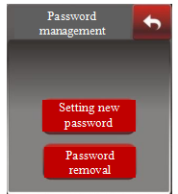

Version information: Click and enter into the version information interface (startup interface).

Note: In case that a user password initial password "1234") is forgotten, please contact with the sales and agency institutions all over the country.

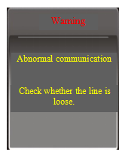
Troubleshooting

I. Abnormal communication

Fault cause:
Poor contact of communication wiring cable;
Damage on communication chip in control panel;
Unstable power supply.

Corresponding solutions:
Check communication wiring cables or combination sockets;
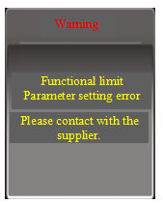
Replace with control panel of the same specifications;
Re-power on for resetting

II. Functional limit

Fault cause:
Users adjust control panel or other applications without
permission from supplier;
Parameter setting error;
Abnormal initialization of system data storage. Corresponding solutions:
Contact the supplier.
Reset data.

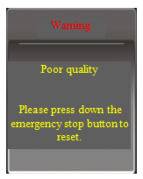
III. Poor quality

Fault cause:
Suspected defective product.

Corresponding solutions:
Press emergency stop button to reset, and check and identify workpieces, molds or equipment problems before continuously processing.

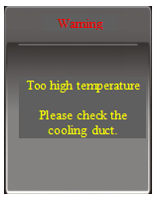
IV. Temperature rise is too high

Fault cause:
Cooling fan gets damaged or cooling air duct blocked;
Higher mold impedance, causing abnormal rising of
output power.
Corresponding solutions:
Replace air fan and check cooling air duct;
Check molds, and start ultrasonic test to determine whether
mold impedance is normal.
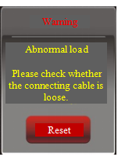

V. Abnormal load

Fault cause:
Transducer wiring cable gets loose or disconnected;
Transducer is affected with damp or positive and
negative electrodes are wired wrongly.
Corresponding solutions:
Press interface resetting button to search for frequency;
Check transducer or connecting cables.

VI. Frequency overrun
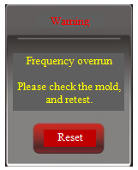
Fault cause:
Mold temperature rising leads to frequency deviated beyond
the maximum working bandwidth;
Loose or damaged mold leads to out-of-tune frequency locking.
Corresponding solutions:
Press interface resetting button to search for frequency;
Cool molds to normal temperature range;
Check molds, and start ultrasonic test to determine whether
mold impedance is normal.

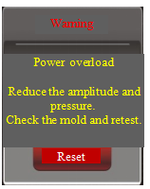

VII. Power overload

Fault cause:
Output power goes beyond the rated power scope.

Corresponding solutions:
Press interface resetting button to search for frequency;
Reduce amplitude or load (such as reducing air pressure);
Replace with ultrasonic power supply of higher power.

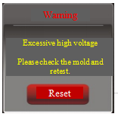
VIII. Over high voltage and current

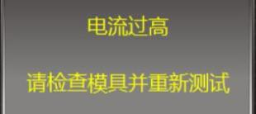
Fault cause:
Excessive high current
Please check the mold and retest.
Peak voltage at two ends of transducer
goes beyond the allowable scope:
Mold impedance is over large or
overloaded.

Corresponding solutions:
Press interface resetting button to search for frequency
Check molds, and start ultrasonic test to determine whether mold impedance is normal. Reduce amplitude or load (such as reducing air pressure);
"Protection sensitivity" can be properly increased for accidental protection.
"Peak voltage" can be properly increased for frequent protection.

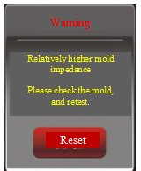
IX. Relatively higher mould impedance

Fault cause:
Mould impedance test goes beyond the allowable scope;
Overload during ultrasonic test (such as workpiece is pressed when the test starts).

Corresponding solutions:
Press interface resetting button to search for frequency
Check mould and modify;
Zero-load ultrasonic test;
"Zero-load impedance threshold" can be properly increased for loaded testing conditions (such as energy collecting bar).

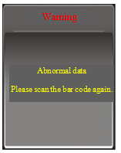

X. Abnormal data

Fault cause:
Data uploaded to the barcode scanner is the same as
that of the previous workpiece.
Corresponding solutions:
Scanning the bar code again;
Checking whether the data on the label of workpiece are the
same;

Note: If the above corresponding fault solutions fail to clear faults, it may be fault inside generator. If so, please contact us.

Quality assurance

Quality guarantee for this product shall be subject to the following regulations:

Warranty only covers generator body, and warranty period starts from the Company's delivery date. Warranty period is twelve months after purchase.

Faults caused by the following reasons belong to paid repair, even within the period warranty:

Problems caused by incorrect operation or repair and modification without permission;

Problems caused by using beyond requirements in standards and specifications;

Damage caused by falling or rude handling after purchase;

Component aging or fault caused by using in environment not meeting requirements in the Manual;

Equipment damage caused by foreign matters entering outside (such as insect);

Equipment damage caused by wiring error;

Faults caused by earthquake, fire, geomantic disaster, lightning strike, abnormal voltage or other natural disasters and causes accompanying with disasters.

The Company is entitled to entrust others for repair for products involved in faults.

Quality warranties under responsibility of the Company, using in China:

a. Warranty within twelve months after delivery.

b. All sales and agency institutions of the Company all over the country can provide after-sales services.

Additional Explanation

About disclaimer:

The Company does not undertake responsibilities caused or induced by using the product violating the Manual.

The Company does not undertake responsibility for compensation against losses or impacted and secondary damages caused to you by faults of the product.

Notice for use:

The Company undertakes lifelong responsibilities for the product, and provides with all services related to the product.

Although the product is designed and manufactured under strict quality control, please be sure to ask us about using purposes where its fault or mis-operation may endanger human body or other lives.

Contact Us

Hotline: 0769-83506468

The Company reserves the right to modify the Manual without previous notice; If any question or problem, please contact with us in time. Your suggestions are warmly welcomed.

